Lab 1: File Management Basics – Creating, Copying, and Moving Files
File management tasks (creating, copying, renaming, moving, deleting files and directories) are among the most common uses of shell scripts. Automating these tasks can save time and reduce errors, especially when dealing with many files.
In this lab, you will write a simple script that demonstrates basic file operations: creating a directory and file, copying the file to a backup location, renaming it, moving it into a new directory, and then cleaning up.
This simulates a real scenario like organizing files or preparing backups of important files.

Learning Objectives
· Understand how to create and remove directories from a script (mkdir, rmdir).
· Practice creating, copying, renaming, and moving files using shell commands (echo/touch, cp, mv).
· Learn to use simple shell variables to define file paths.
· See how to include comments and echo statements for clarity and debugging.

Step-by-Step Instructions
1. Set up the Environment: Open a terminal on your Ubuntu/Linux system. Choose or create a safe working directory (e.g., ~/lab1) to avoid affecting important files. Navigate to this directory.
2. Create the Script File: Use a text editor (nano, vim, etc.) to create a new file named file_manage.sh. This will be your shell script for file management.
3. Write the Script Content: Copy the shell script below into your editor. The script uses variables to define paths and filenames, then performs a series of file operations. Each step is commented for clarity.
4. Save and Make Executable: Save the file and exit the editor. Then run chmod +x file_manage.sh to make the script executable.
5. Run the Script: Execute the script with ./file_manage.sh. It will create a sample directory and file, perform copy/move operations, and echo messages as it works.
6. Verify Results: After it finishes, list the directories to verify outcomes. For example, ls lab1_backup should show the backup file, and the original directories should have been removed as part of cleanup. You’ll also see the echoed progress messages in the terminal.

Shell Script: file_manage.sh
#!/bin/bash
# Lab 1: File Management Basics
# This script creates a directory and file, then copies, renames, moves, and deletes them to demonstrate basic file operations.
# Variables for directory and file names
WORK_DIR="lab1_test" # Working directory to create
BACKUP_DIR="lab1_backup" # Directory for backup copy
FILE_NAME="sample.txt" # Name of the file to create and manipulate
NEW_NAME="sample_renamed.txt" # New name for the file after renaming
echo "Creating directory $WORK_DIR ..."
mkdir -p "$WORK_DIR" # Create the working directory (use -p to avoid error if it exists)
echo "Creating a sample file in $WORK_DIR ..."
echo "Hello, this is a sample file." > "$WORK_DIR/$FILE_NAME" # Create a file with some text in it
echo "Listing files in $WORK_DIR:"
ls -l "$WORK_DIR" # List files to confirm creation (should see sample.txt)
echo "Creating backup directory $BACKUP_DIR ..."
mkdir -p "$BACKUP_DIR" # Create backup directory
echo "Copying $FILE_NAME to backup directory..."
cp "$WORK_DIR/$FILE_NAME" "$BACKUP_DIR/" # Copy the file to the backup directory
echo "Renaming $FILE_NAME to $NEW_NAME ..."
mv "$WORK_DIR/$FILE_NAME" "$WORK_DIR/$NEW_NAME" # Rename the file in the original directory
echo "Moving $NEW_NAME into a new subdirectory..."
NEW_SUBDIR="$WORK_DIR/subdir"
mkdir -p "$NEW_SUBDIR" # Create a new subdirectory
mv "$WORK_DIR/$NEW_NAME" "$NEW_SUBDIR/" # Move the renamed file into the new subdirectory
echo "Deleting the file in subdirectory..."
rm "$NEW_SUBDIR/$NEW_NAME" # Delete the file
echo "Cleaning up directories..."
rmdir "$NEW_SUBDIR" # Remove the now-empty subdirectory
rmdir "$WORK_DIR" # Remove the now-empty original directory
# (We keep the backup directory and file for verification)
echo "File operations complete. Backup copy is in $BACKUP_DIR."
Script Explanation:
The script uses mkdir to create directories (with -p to create parent directories if needed), echo "text" > file to create a file with content, cp to copy the file to a backup location, and mv to rename and later move the file.
The rm command removes the file, and rmdir removes empty directories. Each major step is announced with echo so you can follow what the script is doing.
Be cautious with rm and rmdir – deleting files is irreversible, so the script confines itself to the lab directories.

Sample Output
To execute the script run the following commands.

chmod +x file_manage.sh

./file_manage.sh
When you run the script, you should see output similar to the following, indicating each operation’s success:
Creating directory lab1_test ...
Creating a sample file in lab1_test ...
Listing files in lab1_test:
total 4
-rw-rw-r-- 1 user user 28 Aug 18 14:33 sample.txt
Creating backup directory lab1_backup ...
Copying sample.txt to backup directory...
Renaming sample.txt to sample_renamed.txt ...
Moving sample_renamed.txt into a new subdirectory...
Deleting the file in subdirectory...
Cleaning up directories...
File operations complete. Backup copy is in lab1_backup.
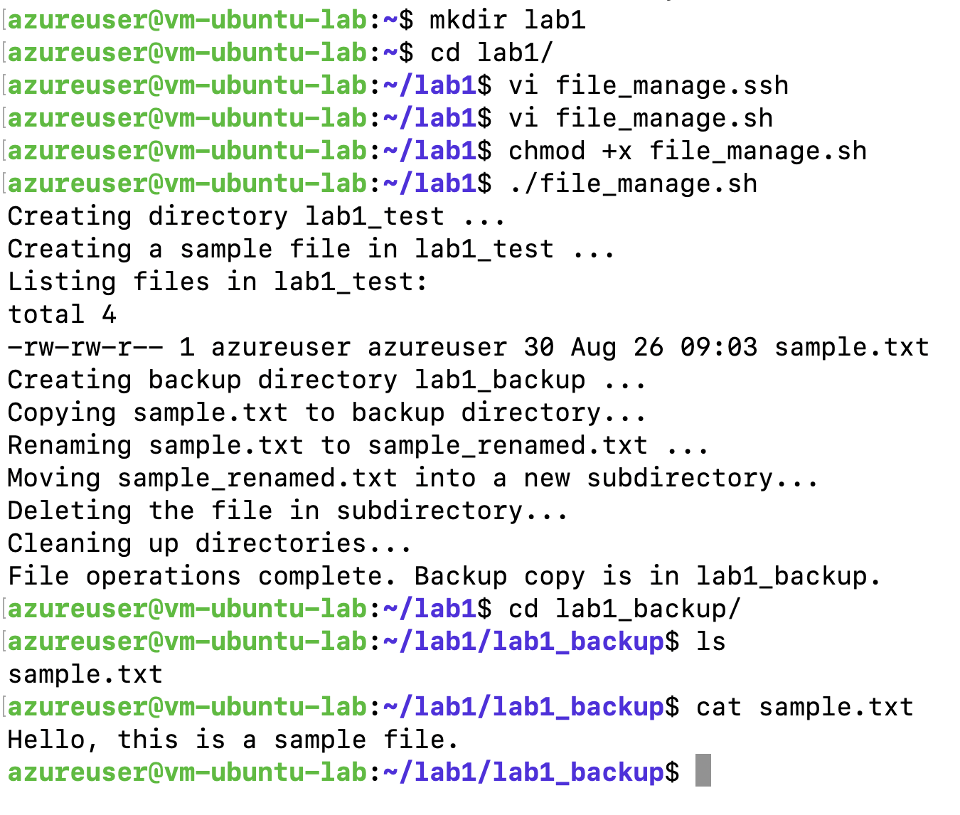
After running, if you check lab1_backup, it should contain sample.txt (the copied file), while the original working directory has been removed. This confirms the script successfully performed all file management steps. Feel free to open the lab1_backup/sample.txt file to see its content ("Hello, this is a sample file.").

